Adobe Experience Platform

Data Pipeline

# Lab Overview

In this lab, we will use Import Mapping capability to import Orders historical data mapping into streaming ingestion flow. Data will be ingested using Streaming HTTP API.

**Expected time: 30 minutes**

# Learning Objectives

What should you walk away with after taking this Lab?

* Creating a Streaming Inlet
* Importing mapping set from another Dataflow
* Get Dataflow ID, and Dataset ID from the UI
* Using REST API to ingest an event

# Lab Tasks – Orders – Live data (Streaming)

In this exercise, we will load the Orders data from Streaming source to AEP Data Lake and Profile.

**Pre-requisites**

1. Orders JSON file is downloaded from Azure ADLS and available on your local system
2. Orders Schema and Dataset are already created

**Steps**

Go to Adobe Experience Platform à **Sources** à **Catalog** à **Streaming**. Click on **Setup** / **Add Data** for the HTTP API.

|  |  |
| --- | --- |
| Tip | If at least one connection exists for that source, you will see “**Add data**” as the default action. If no connections exist for that source, you will see “**Setup**” as the default action. |

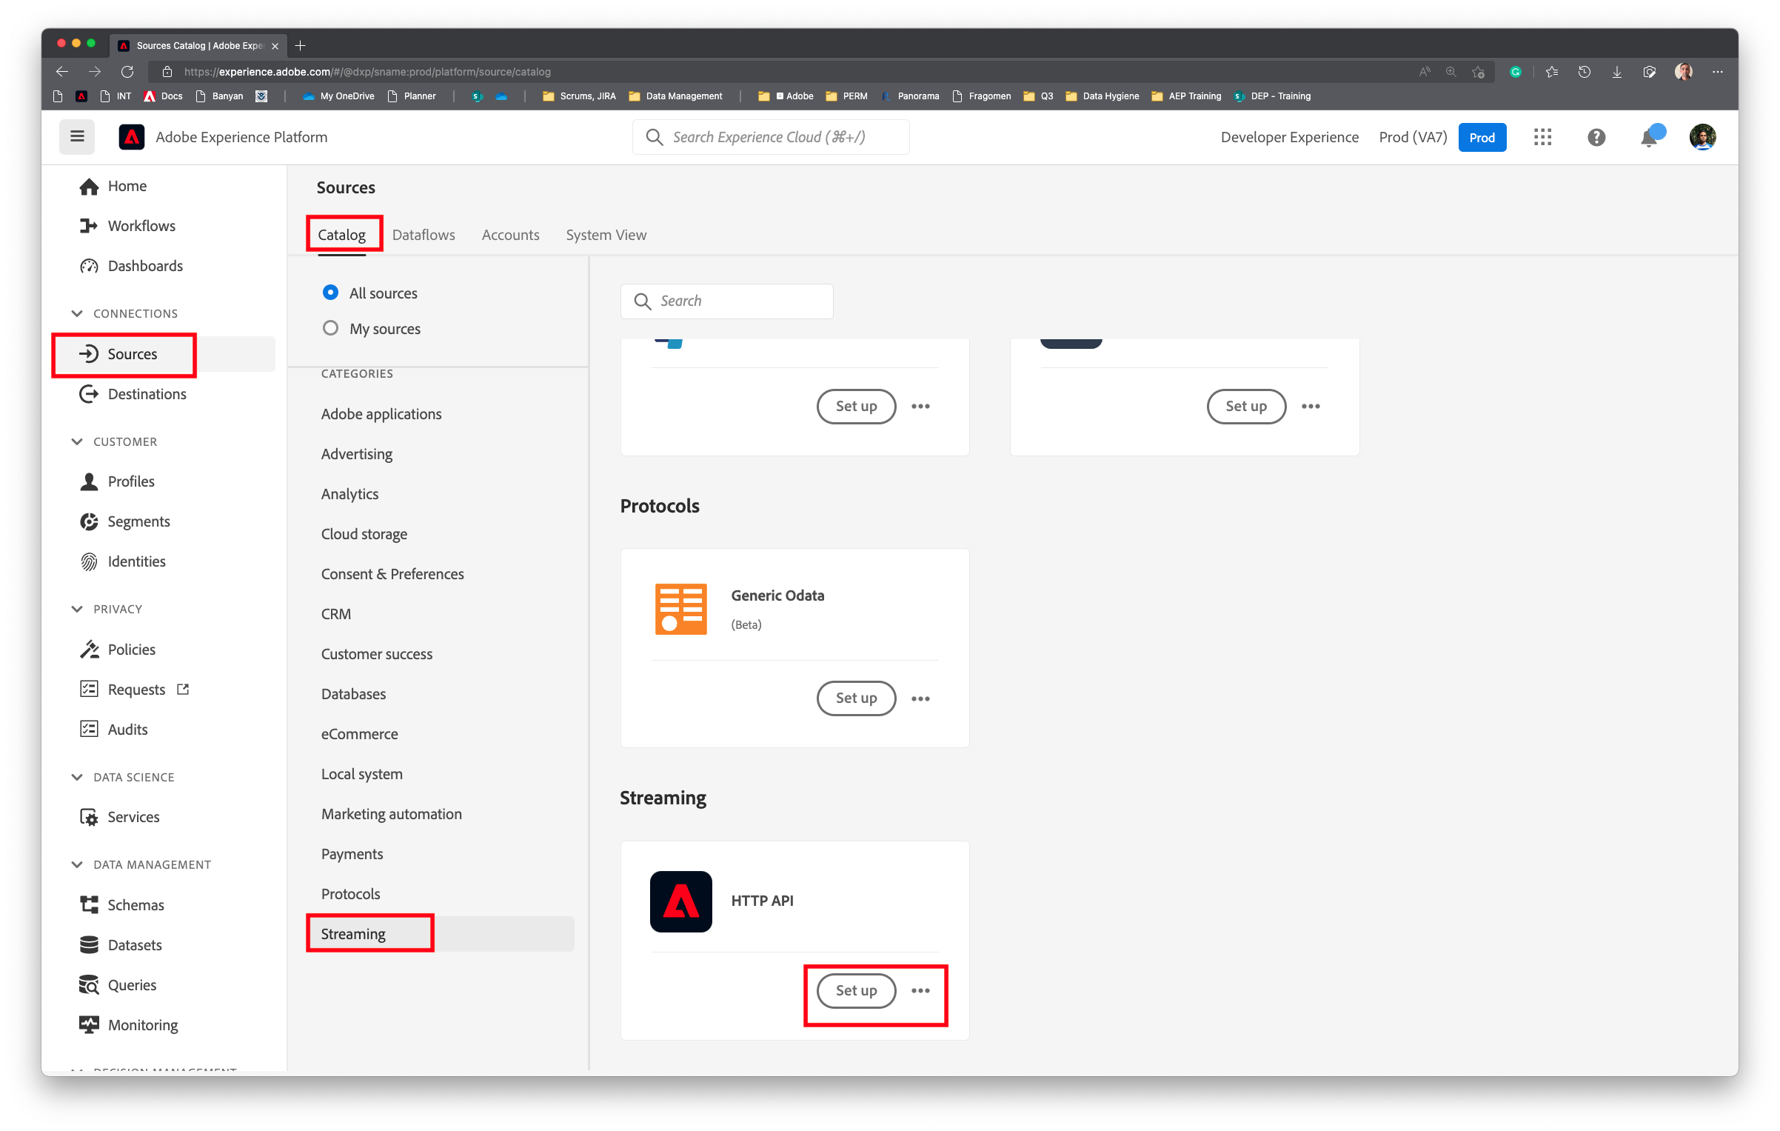

## Create a Streaming Inlet

In the Streaming Source, create a **New account** as shown in the screenshot below. For the new account, type the name as **Orders Live Stream**. Click **Connect to source**. Enable authentication must be OFF (default). XDM Compatible must be unchecked (default).

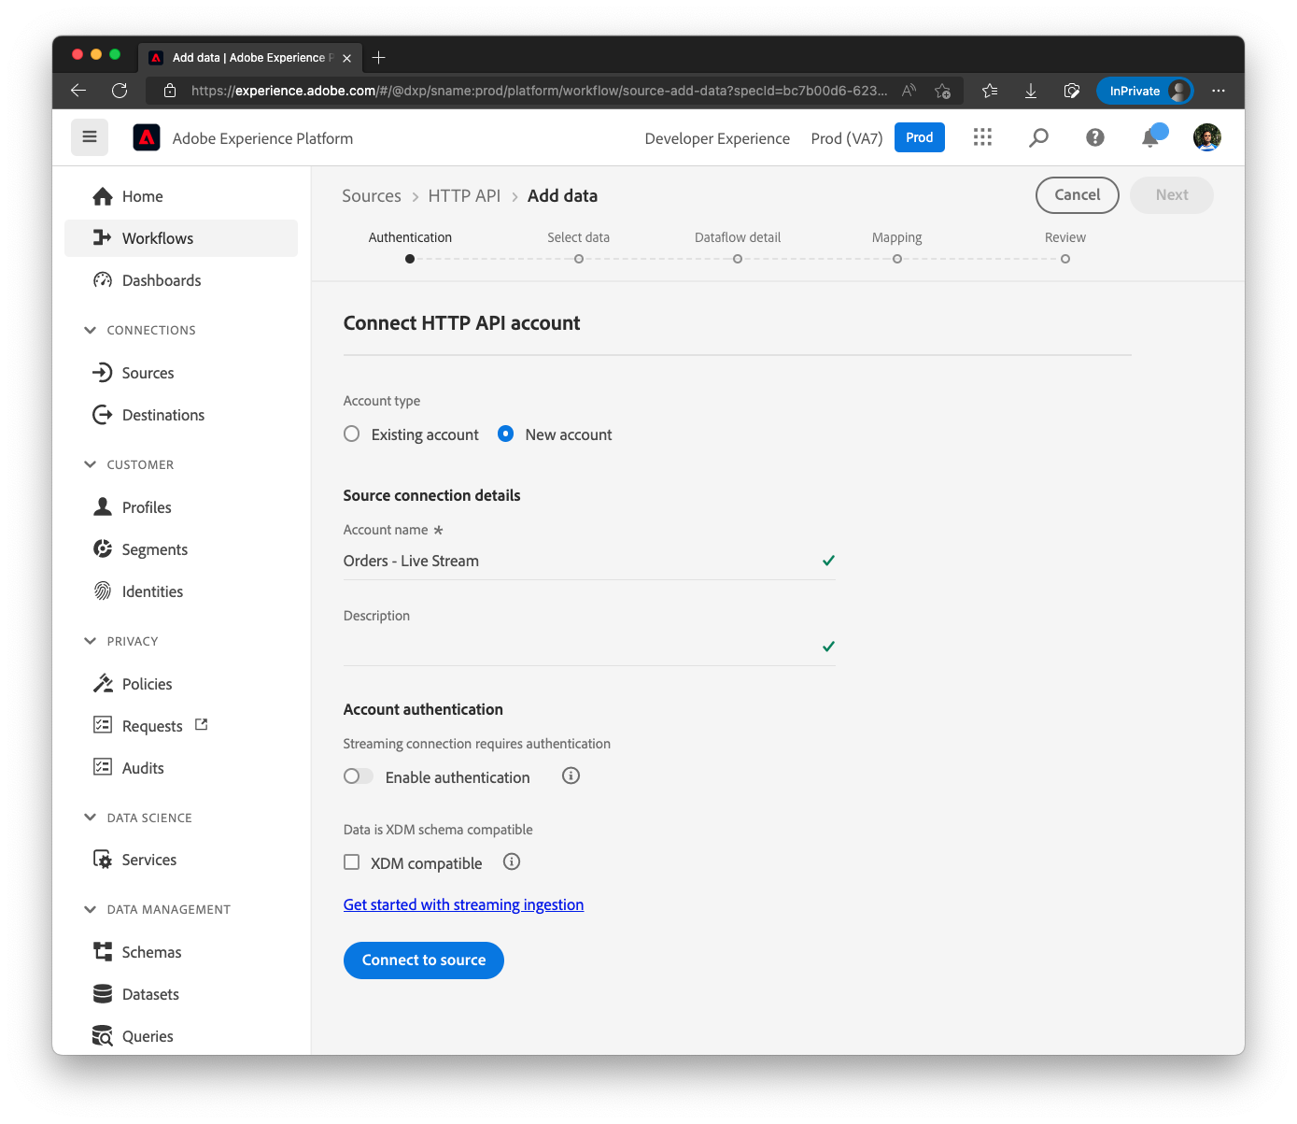

Once account is created, **Connected** message is displayed at the bottom. Click **Next** on the top right to continue.

## Upload sample data

Click **Upload files** and select the Orders JSON file (**Lab_Single_Order.json**) from local file system. Data Preview loads automatically. Click **Next**.

|  |  |
| --- | --- |
| Warning | Do not use the **Orders_CLIENT.json** that was used in the Orders Historical load. There is currently a UI bug that will fail the Import Mapping if that file is used. |

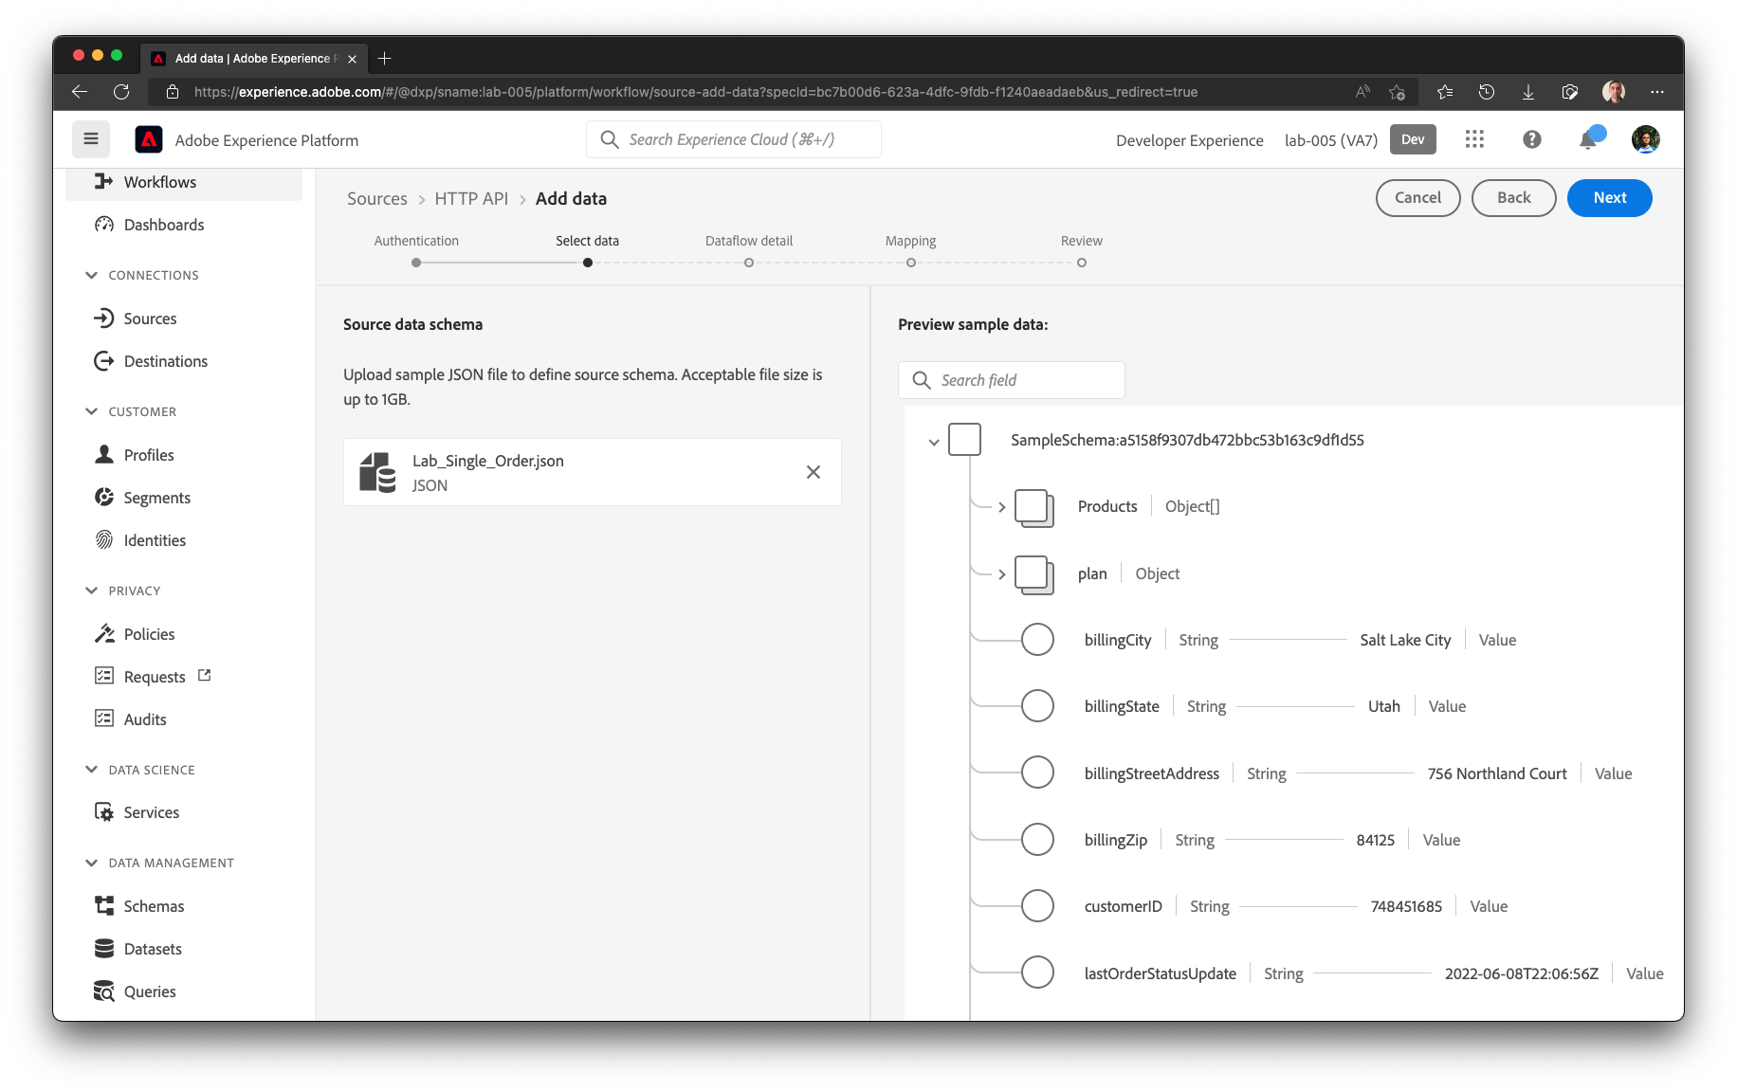

## Define the Target dataset

In the screen, select existing dataset and choose **dep: Orders learner**. Set the Dataflow name as **Orders – Live Stream**. Enable the Dataset for Profile. By toggling the **Profile dataset** box.

## Data Prep / Transformation

In the Data Prep (mapping) screen, Click on Import mapping button

Select **Dataflow – Orders – Backfill** and click **Select**.

Mapping is now imported. All the previously existing mappings are Removed. Click Next.

Click on the icon to preview mapping output. Ensure there are no red exclamations next to any attributes

The final mapping set will look similar to this

Click Next to continue, review the Dataflow and save it by clicking Finish.

The Dataflow is now created. Ensure the status of the Dataflow is **Enabled** so that it is ready to receive events.

## Ingest Live Data

We will ingest the live data using a REST API call to our HTTP API Endpoint. To do this, we will need the following:

1. Streaming Endpoint
2. Dataflow ID
3. IMS Org ID
4. Dataset ID

### Get the Streaming Endpoint

In the current screen, right hand side, note the Streaming endpoint.

|  |  |
| --- | --- |
| Tip | If you do not see this information, most likely the Dataflow is selected on the left. Click on the Dataflow row (not the blue link) on the left again to unselect it. |

### Get Dataflow ID and Dataset ID

In the current screen, select the dataflow name, scroll down the right hand panel and take a note of the Dataflow ID and Dataset ID from the **API Usage** section.

### Place a REST API call

In the Postman UI, set the following

Type: POST

URL: « Streaming Endpoint »

Body: The below structure.

**Replace your flowId, and datasetId.**

|  |
| --- |
| {  "header": {  "flowId": "8a2a790d-f4fa-4165-ab3f-a4e40d02aecb",  "imsOrgId": "37E0399C61687C4E0A495E06@AdobeOrg",  "datasetId": "62e0b18f7303841c072d31ae"  },  "body": {    }  } |

Add the JSON request body as follows.

Change the following attributes to make it unique:

* **personalEmail** (Identity attribute)
* **customerID** (Identity attribute)
* **OrderID** (used to uniquely build _id)
* **lastOrderStatusUpdate** (used to uniquely build _id and timestamp)

|  |  |
| --- | --- |
| WARNING | Make sure these attributes are unique. If the row is not unique, system will not warn and the event will be ignored (not reported as warning / error). |

|  |
| --- |
| "body": {  "orderStatus": "placed",  "lastOrderStatusUpdate": "2022-08-11T17:43:01Z",  "customerID": "081120221743001",  "personalEmail": "keshav-aug-11-2022-17-43@adobe.com",  "orderID": "f82af383-cc27-427b-a97e-4ed4340d3e9a-aug-11-2022-17-43-01",  "orderDate": "2022-08-11T17:43:01Z",  "orderTotal": 291.02,  "paymentType": "credit",  "paymentAmount": 349.35,  "paymentCurrencyCode": "USD",  "paymentTransactionID": "24596662-1a9b-4fc1-a98f-b5ca687c523f",  "storeID": "STORE-35",  "shippingStreetAddress": "30133 Golf Parkway",  "shippingCity": "Fullerton",  "shippingState": "California",  "shippingZip": "92640",  "shippingMethod": "Standard",  "shippingAmount": 0,  "shippingDestination": "store",  "billingStreetAddress": "497 Kensington Drive",  "billingCity": "Glinojeck",  "billingZip": "06-450",  "plan": {  "ID": "m3"  },  "Products": [  {  "productID": "PRODUCT-6",  "quantity": 1,  "price": 150.23,  "currencyCode": "USD",  "model": "v2",  "make": "Google"  },  {  "productID": "PRODUCT-11",  "quantity": 1,  "price": 150.23,  "currencyCode": "USD",  "model": "v1",  "make": "Google"  }  ]  } |

Click Send and the event will be posted to the Streaming Endpoint. The response body will be similar to this:

|  |
| --- |
| {  "inletId": "97396a78fe0d5220c5335995ce9af9be7a419413b2a84175fa349651f68e50cc",  "xactionId": "1658959385898:6455:243",  "flowId": "8a2a790d-f4fa-4165-ab3f-a4e40d02aecb",  "receivedTimeMs": 1658959385898  } |

## Verify data in Profile

Go to Adobe Experience Platform 🡪 Profiles in the left Nav bar and click on the Browse on the top.

In the Merge policy below, select the following and click View. Profiles matching the criteria will load in few minutes. Click on the Profile ID link

|  |  |
| --- | --- |
| Merge policy | Default Timebased |
| Identity namespace | Email |
| Identity value | « Email address provided in the PostMan API in the **personalEmail** attribute » |

Profile gets loaded. This profile was originally loaded via Customer Accounts Lab (Lab 2). Click on the Events tab.

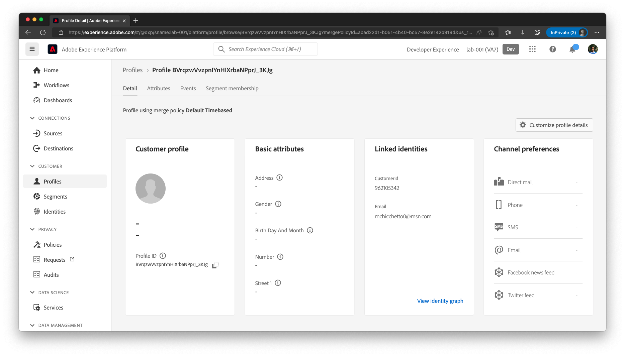

Events tab shows the Event received as “**placed**”

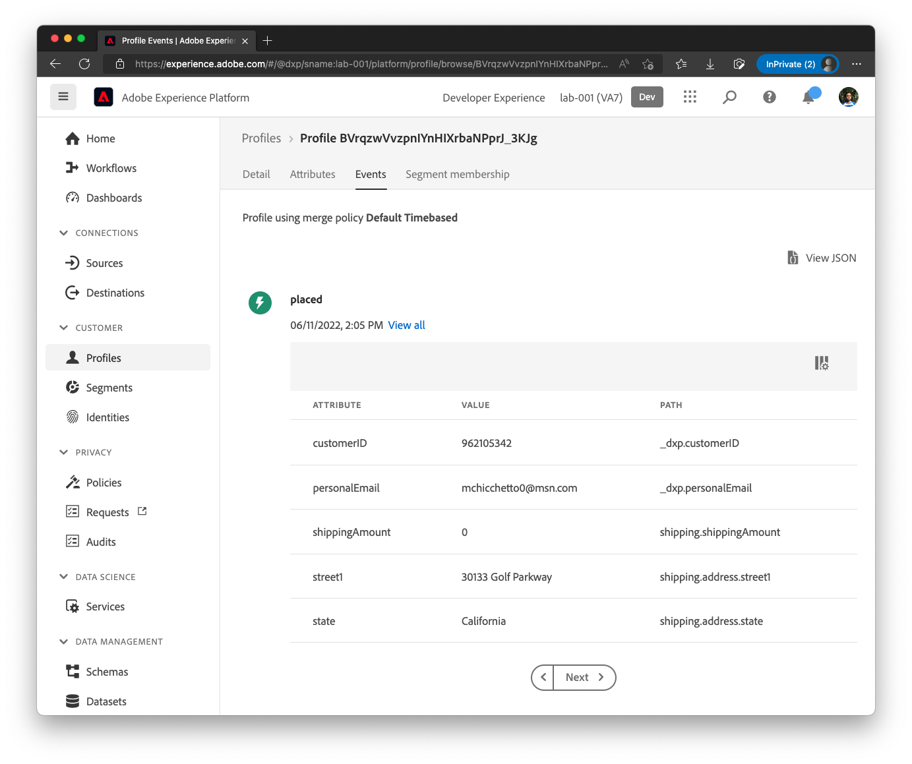

Switch to the Postman and update the following

|  |  |
| --- | --- |
| Attribute | Change |
| orderStatus | cancelled |
| lastOrderStatusUpdate | « New time » |
| OrderID | « Add a suffix to make it unique » |

event type to “**cancelled**” for the same event, change the last digit of the order id from “**a**” to “**b**” and click **Send**.

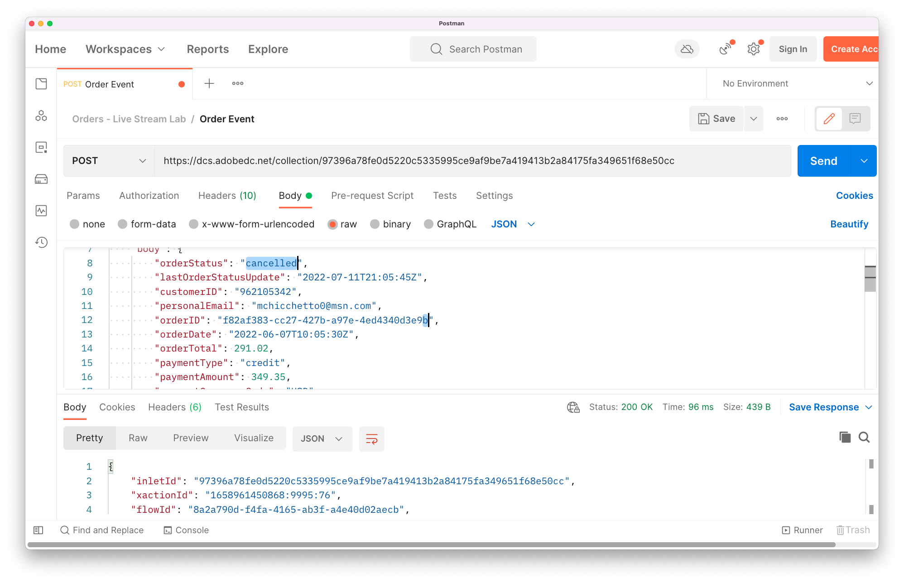

Switch to Profile screen and refresh the page. You will notice that the new event of type cancelled has also arrived in Profile

